North Eastern Regional Agricultural Marketing Corporation Ltd (NERAMAC)

Invites Quotation For
Supply, Installation and Commissioning of Kiosk at
Srimantapur Sonamura ICP, Tripura.

Document No. NER/MKTG/151/21/387

For Document: Please visit www.neramac.com

REGISTERED OFFICE ADDRESS :
9, Rajabari Path, G.S Road, Ganeshguri, Guwahati 781005, Kamrup (Metro) Assam, India

Quotation for Supply, Installation and Commissioning of Kiosk at Srimantapur land port , Tripura

North Eastern Regional Agricultural Marketing Corporation Ltd (NERAMAC) invites Quotation for Supply, Installation and Commissioning of Kiosk at Srimantapur ICP, Tripura. The interested Company/Firm/Agency may download the terms and conditions and format for bid submission from website: www.neramac.com the quotation along with all the required document must reach the office of North Eastern Regional Agricultural Marketing Corporation,9 Rajbari Path, Ganeshguri, Guwahati- 781005, Assam latest by 18 September 2023 on or before 4.00 pm positively. The Envelope containing the quotation and document would please be sealed and super scribed as under:-

“Quotation for Supply, Installation and Commissioning of Kiosk at Srimantapur ICP, Tripura”

Contact person:-

Shri Shankar Nath
DM, Marketing
Ph. No.+91- 86389 95055

Important Dates:

Last date and time for the submission of Bid : 18 September 2023 on or before 4.00 PM.
Date of opening of Bids : 19 September 2023 at 12.00 noon
Place of submission and opening of Bids : NERAMAC HEAD OFFICE 9, Rajbari Path, Ganeshguri, Guwahati, Assam.

In case the date of opening falls on a holiday, the bids shall be opened on the next working day at the same time and it will be binding on the Tenderer / Bidders for acceptance.

General Terms & Conditions:

- Any bids received after the deadline shall not be entertained under any circumstances whatsoever. In case of postal delay this Institute will not be responsible. Unsealed bid shall rejected.

- Non Refundable Tender Fees of Rs 2000/- needs to be deposited in the name of NERAMAC LTD. State Bank of India. New Guwahati Branch, A/C No 10566982782; IFSC Code SBIN0000221.

- Bids must be in the enclosed prescribed Performa on the letter head of the firm duly signed by the Proprietor/ Partner/ Director or their authorized representative. In case of signing of bid by the authorized representative letter of authorization must be attached with the bid.

- Rates must be quoted in Indian rupees and as per the format specified, taxes extra if any, must be written separately.

- Rates must be quoted FOR basis (including Freight charges, Insurance, installation etc.)

- No overwriting or scribing is permitted in the rate. If found, the quotation shall be summarily rejected.

- The rates quoted shall be valid for a period of 90 days from the date of opening of the quotation. If NERAMAC receives no communication/intimation in this regard from the bidder, this condition shall be deemed as agreed by the bidder.

- RTGS/NEFT details need to be furnished by the supplier with the bid on the letter head of supplier/firm/agency.

- The following conditions and self-attested copy of the same are to be attached with the bid:

  - Copies of Original documents defining the constitution or legal status, place of registration, and principal place of business; written power of attorney of the signatory of the Bid to commit the bidder.

  - Should have valid Registration Certificate / Trade License / PAN Card / GST Registration.

  - The bidding Company / Firm / Agency must have carried our branding related works in the last 3 years with organizations of repute. Copies of Purchase Orders are required to be enclosed with the Quotation.

  - The bidding Company / Firm / Agency should have service facility in, Tripura and should be capable to render service within 24 hrs.

  - The bidding Company / Firm / Agency should not be blacklisted by Central or State Government or Government Organizations / Agencies.

- The successful bidder shall be bound to supply the items at such agreed rate and terms during the said period. This validity period may be further extended by one year with mutual consent.

- No Bidder shall be allowed at any time on any ground whatsoever to claim revision or modification in the rates quoted by him. Representation to make correction in the bid documents on the ground of clerical error, typographical error, etc., committed by the firm / agency in the bid shall not be entertained after submission of the bids.

- The Management of NERAMAC reserves the right to cancel the bid without assigning any reason whatsoever.

- In the event of any dispute or differences arises between the successful bidder and NERAMAC in relation to this bid, the construction of any provision thereof or duties or liabilities of the successful bidder, the parties shall make effort to negotiate and settle their disputes amicably. When the parties fails to arise at an amicable settlement, the dispute shall be referred to a sole Arbitrator be appointed by MD, NERAMAC. The venue of arbitration shall be at Guwahati.

- Successful Company / Firm / Agency shall have to execute an agreement as specified from the date of dispatch of letter of acceptance.

- Time of Completion – 30 days post letter of Acceptance.

- If the supplier fails to deliver the material on or before the stipulated date, then a penalty at the rate of 0.5 % per week of the total order value shall be levied subject to maximum of 10% of the total order value.

- Payment will be made only after satisfactorily delivery / installation of the material and after inspection by the officials of NERAMAC. Payment shall be made only for the quantity supplied.

- An amount of 10% of the billing amount will be retained for a period of 1 year i.e defect liability period.

I/We have read and examined the notice for quotation, general terms and condition annexure, specifications and all other documents referred for the work and accept the terms and conditions of the tender in full conformity.

Date :

Place :
SEAL & SIGNATURE OF THE FIRM/AGENCY

ANNEXURE “A”
BIDDER’S PROFILE

( To be submitted on tenderer’s Letter-Head )

- Name of the Organization and Address:

- Status of the firm:
Whether Pvt. Ltd. company / Pubic Ltd. company/ Partnership Firm / Proprietorship Firm

- Whether registered with the Registrar of Companies/Registrar of Firms in India. If so, mention number and date and enclose Registration Certificate copy.

- Name and address of Bankers :

- Turnover of the Company/Firm in: 2020-21
2021-22:
2022-23:
(Please attach a copy of audited Balance Sheet and Profit & Loss Account certified by Chartered Account.

- Whether registered for GST Certification. If so, mention number and date. Also furnish copies of certificate.

- Whether an assesses of Income Tax. If so, mention Permanent Account Number.

- Furnish the names of renowned organizations, where you have supplied/ installed similar branding Elements– Furnish Details.

Date :

Place :
SEAL & SIGNATURE OF THE FIRM/AGENCY

ANNEXURE “B”

PRICE BID :-

( To be submitted on tenderer’s Letter-Head )

TECHNICAL SPECIFICATION | QUANTITY | UNIT RATE  (Inclusive of Taxes | TOTAL AMOUNT
Kiosk-Size 10’ x 10’  Material to be used is ACP, Aluminum Channel, Waterproof Ply board, Toughened Glass, Spray Painted, Gypsum Board , LED Lights, Sunboard Vinyl , Aluminum Shutter.  Inside Sitting arrangement with table for 2 pax.  Spot Lights on the Display Counters.  Ancillary Electrical works for light/fittings and  fixtures/equipments like Juicer, Computer/Billing Machine etc.  Acrylic lit raised letter- (3 nos.) for stall name.  NERAMAC Branding on Acrylic & ACP Back sheet  Any other Ancillary works if required as per site condition (Design enclosed in Annexure –C) (No any deviation to be made in design) | 1 NOS.

Date :

Place :
SEAL & SIGNATURE OF THE FIRM/AGENCY

ANNEXURE C- KIOSK MODEL DESIGN

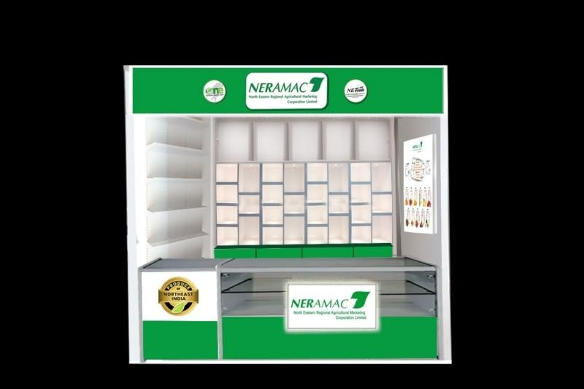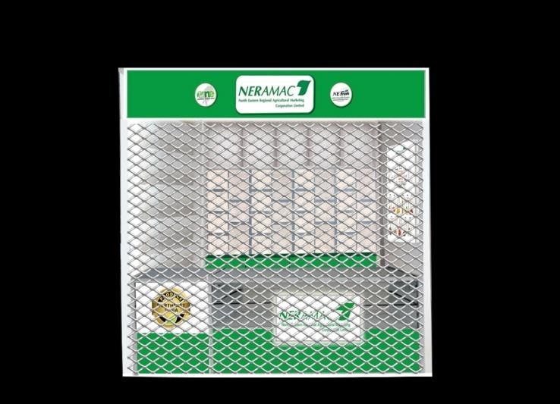

OPEN VIEW CLOSED VIEW

Date :

Place : SEAL & SIGNATURE OF THE FIRM/AGENCY

ANNEXURE D

(ON STAMP PAPER OF Rs.10 DULY NOTARIZED)

DECLARATION BY THE FIRM/AGENCY

  - I (Name of the person), am authorized to declare on behalf of the agency / Organization / Society (Name of the Agency/ Organization / Society) hereby declare that the agency has Full-fledged office establishment in India with needed manpower.

  - I also declare that all the statements made in this application are true, complete and correct to the best of my knowledge and brief. I understand that if at any stage, it is found that any information given in this application is false / incorrect or that our Agency/Organization/Society does not satisfy the eligibility criteria, our candidature/empanelment is liable to be cancelled/ terminated.

  - I understand that the decision taken is final in all matters.

  - I hereby agree to work as per the terms and conditions rolled out by NERAMAC.

  - I understand that NERAMAC reserves the right to accept or reject and to cancel the empanelment process and reject all expression of interests at any time prior to the award of contract, without assigning any specified reasons whatsoever.

Date :

Place :
SEAL & SIGNATURE OF THE FIRM/AGENCY

